Background
This tool has six categories of performance, and each are weighted when calculating an overall ‘utility’ for the package. It is not currently possible to change the weightings – that will require time we don’t have right now .

Table 1 - Category weighting

Performance Category | Default weighting  (percent)
Crop losses | 50
User health and safety | 12.5
Direct costs | 12.5
Environmental impact | 12.5
Time and management | 6.25
Third party coordination requirements | 6.25

Table 2 – User provided ratings
User Rating | Assigned Value
1 – Not acceptable | 1
2 – Likely to dissuade from use | 2
3 – Will be a consideration in decision to use | 3
4 - Acceptable | 4
5 – Highly acceptable or improved | 5

Note that you will need to assign a confidence to your assessments (Table 3).

Table 3 – User provided confidences
Confidence rating | Percent of distribution alotted to selected rating
Very high | 90%
High | 80%
Medium | 50%
Low | 35%

Figure 1 shows how the user rating and confidence scores are combined to create the ‘value distribution’.
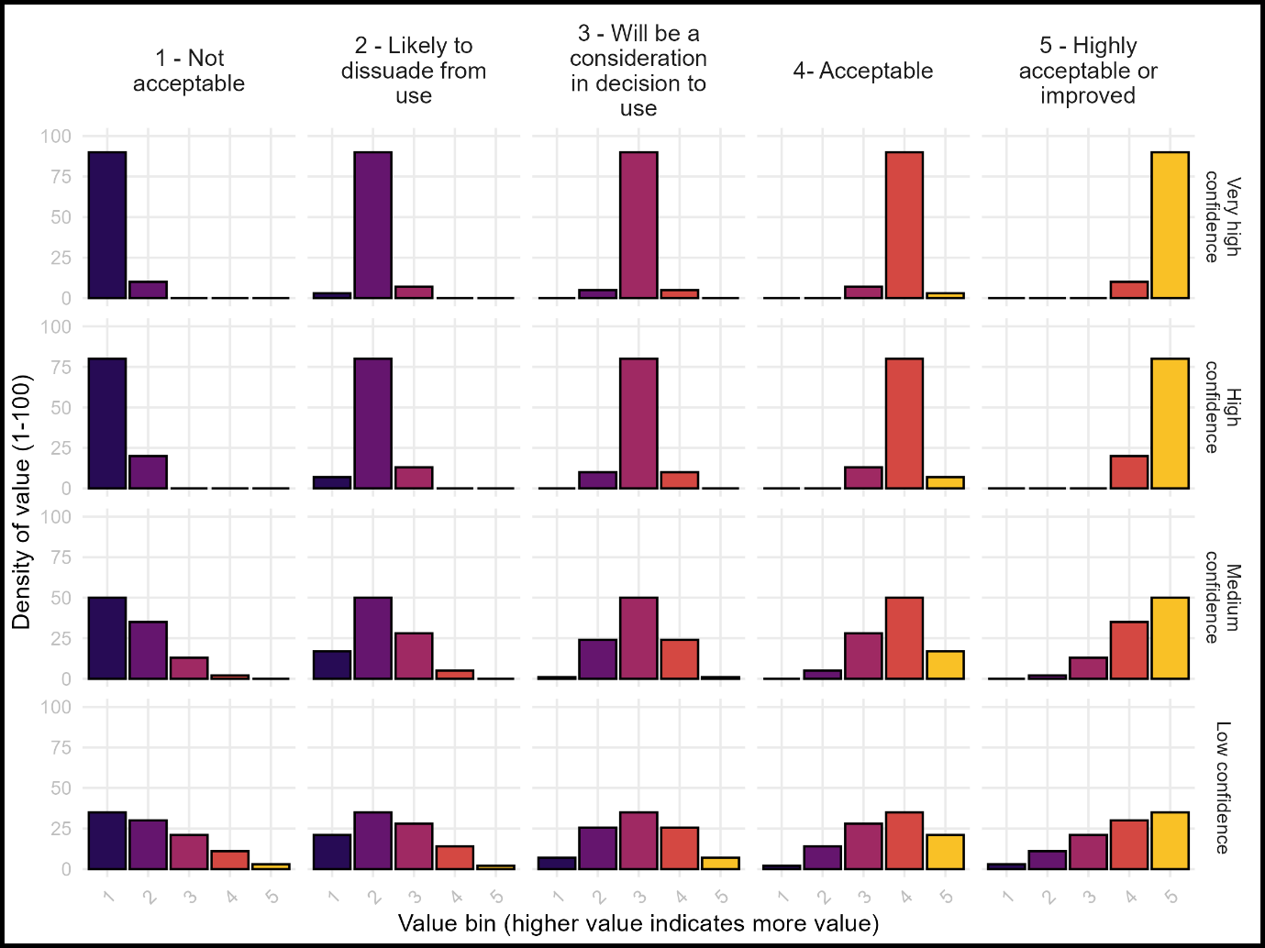

Questionaire
The following questionnaire should be filled out for both Package #1 and #2.

Crop losses
This is a measure of the success and therefore the acceptability of the yields and quality obtained using this technology/package. The smaller the loss of yield and/or quality the greater the acceptability.
Loss in crop yield and/or quality when using the technology/package is:
1 – Not acceptable | 2 – Likely to dissuade from use | 3 – Will be a consideration in decision to use | 4 - Acceptable | 5 – Highly acceptable or improved

My confidence in this rating is:
Low | Medium | High | Very high

Some things to consider:
- Opportunity costs when implementing the practice(s), for example if you take strips of land out of production to install natural habitat to support natural enemies.
- An increase in crop value due to new markets available, for example by producing pesticide-free products

User health and safety
This is for factors other than any pesticides used as these are assessed and calculated from the pesticide application data using the Pesticide Impact Explorer (PIE) tool.
Worker exposure to health and/or safety risks is:
1 – Not acceptable | 2 – Likely to dissuade from use | 3 – Will be a consideration in decision to use | 4 - Acceptable | 5 – Highly acceptable or improved

My confidence in this rating is:
Low | Medium | High | Very high

Some things to consider:
- Exposure to physical risks, such as the use of ladders when implementing the practice
- Does it involve activities that must be done at night, or during the heat of the day
- You should think about health and safety issues not relating to the use of pesticides – there is an additional tool (Pesticide Impact Explorer (PIE) that allows you to enter the pesticide applications and get a numeric estimate of risk, as well as societal costs

Direct costs
This is a measure of the value delivered against the cost of the package.
The net cost of the technology/package to implement is:
1 – Not acceptable | 2 – Likely to dissuade from use | 3 – Will be a consideration in decision to use | 4 - Acceptable | 5 – Highly acceptable or improved

My confidence in this rating is:
Low | Medium | High | Very high

Some things to consider:
- Does it require upfront costs that take time to see a return on investment, for example buying a mechanical weeding implement.
- Does it require time before the return on investment is realized, or is it realized immediately, for example planting of a diverse flower buffer versus re-establishing native habitat.

Environmental impact
This is for factors other than any pesticides used as these are assessed and calculated from the pesticide application data using the Pesticide Impact Explorer (PIE) tool.
The potential environmental impact of the practice(s) is/are:
1 – Not acceptable | 2 – Likely to dissuade from use | 3 – Will be a consideration in decision to use | 4 - Acceptable | 5 – Highly acceptable or improved

My confidence in this rating is:
Low | Medium | High | Very high

Some things to consider:
- Does the practice impact greenhouse gas emissions, for example by requiring more tractor passes
- Does the practice impact water quality, for example by reducing nitrogen applications
- Does the practice support biodiversity, for example by establishing flower strips along field borders

Time and management
The impact of implementing the package on time and management considerations, outside of those captured by direct costs.
The time and/or effort requirement of the user to implement and/or maintain the effectiveness of the practice(s) is:
1 – Not acceptable | 2 – Likely to dissuade from use | 3 – Will be a consideration in decision to use | 4 - Acceptable | 5 – Highly acceptable or improved

My confidence in this rating is:
Low | Medium | High | Very high

Some things to consider:
- Does the practice require certain skills or training?
- Does the practice require careful timing of application?

Third party coordination requirements
Whether implementation requires additional supply chains, infrastructure, or cooperation that may be outside of the user’s direct control.
The coordination required for the technology/package to be effective is:
1 – Not acceptable | 2 – Likely to dissuade from use | 3 – Will be a consideration in decision to use | 4 - Acceptable | 5 – Highly acceptable or improved

My confidence in this rating is:
Low | Medium | High | Very high

Some things to consider:
- Can a producer implement the practice(s) immediately, or do they require training to run a spot sprayer
- Can the producer implement it now, or do they need to hire a third-party to, for example, spray pesticides using a drone
- Does the practice require establishment of supply chains, for example a new biological control agent or a new crop variety
- Does the practice require coordination with neighbors, for example establishment of buffer areas

